

# Olivia-A Personal Virtual Assistant

A Report submitted in partial fulfillment of the

requirement for the degree of



B.Tech

In

Computer Science and Engineering

Under the Supervision of

Ms. Sonam kumari and

Ms. Shail ja

By

**Chirag Singhal (2000330100084)**

**Raj Kumar Goel Institute of Technology Ghaziabad**

***5th KM. STONE, DELHI-MEERUT ROAD, GHAZIABAD (U.P)-201003***

**Department of Computer Science & Engineering**

Session: - 2021-2022

# Declaration

This is to certify that Mini Project Entitled “Olivia-A Personal Virtual Assistant” which is submitted in partial fulfillment of the requirement for the award of degree B.Tech. in Computer Science and Engineering to R.K.G.I.T, Ghaziabad, Dr. A.P.J. Abdul Kalam Technical University, Lucknow comprises only original work and studies carried out by students himself. The matter embodied in this report has not been submitted for the award of any other degree.

**Date: 20th December 2020**

**Approved By : Signature**

**Ms. Sonam kumari** **(Assistant Professor) Mini-Project /Internship Co-Ordinator(2nd Year) CSE Department RKGIT, Ghaziabad**

**Counter sign By : Signature**

**Dr. Sachi Gupta (Professor)**

**HOD, CSE Department RKGIT, Ghaziabad**

### VISION OF THE INSTITUTE

To continually develop excellent professionals capable of providing sustainable solutions to challenging problems in their fields and prove responsible global citizens.

### MISSION OF THE INSTITUTE

We wish to serve the nation by becoming a reputed deemed university for providing value based professional education.

### VISION OF THE DEPARTMENT

To be recognized globally for delivering high quality education in the ever-changing field of computer science & engineering, both of value & relevance to the communities we serve.

### MISSION OF THE DEPARTMENT

1. To provide quality education in both the theoretical and applied foundations of Computer Science and train students to effectively apply this education to solve real world problems.
2. To amplify their potential for lifelong high-quality careers and give them a competitive advantage in the challenging global work environment.

### PROGRAM EDUCATIONAL OUTCOMES (PEOs)

**PEO 1: Learning:** Our graduates to be competent with sound knowledge in the field of Computer Science & Engineering.

**PEO 2: Employable:** To develop the ability among students to synthesize data and technical concepts for application to software product design for successful careers that meet the needs of Indian and multinational companies.

**PEO 3: Innovative:** To develop research oriented analytical ability among students to prepare them for making technical contributions to the society.

**PEO 4: Entrepreneur / Contribution:** To develop excellent leadership quality among students which they can use at different levels according to their experience and contribute for progress and development in the society.

### PROGRAM OUTCOMES (POs)

Engineering Graduates will be able to:

**PO1: Engineering knowledge**: Apply the knowledge of mathematics, science, engineering fundamentals, and an engineering specialization to the solution of complex engineering problems.

**PO2: Problem analysis**: Identify, formulate, review research literature, and analyze complex engineering problems reaching substantiated conclusions using first principles of mathematics, natural sciences, and engineering sciences.

**PO3: Design/development of solutions**: Design solutions for complex engineering problems and design system components or processes that meet the specified needs with appropriate consideration for the public health and safety, and the cultural, societal, and environmental considerations.

**PO4: Conduct investigations of complex problems**: Use research-based knowledge and research methods including design of experiments, analysis and interpretation of data, and synthesis of the information to provide valid conclusions.

**PO5: Modern tool usage**: Create, select, and apply appropriate techniques, resources, a n d modern engineering and IT tools including prediction and modelling to complex engineering activities with an understanding of the limitations.

**PO6: The engineer and society**: Apply reasoning informed by the contextual knowledge to assess societal, health, safety, legal and cultural issues and the consequent responsibilities relevant to the professional engineering practice.

**PO7: Environment and sustainability**: Understand the impact of the professional engineering solutions in societal and environmental contexts, and demonstrate the knowledge of, and need for sustainable development.

**PO8: Ethics**: Apply ethical principles and commit to professional ethics and responsibilities and norms of the engineering practice.

**PO9: Individual and teamwork**: Function effectively as an individual, and as a member or leader in diverse teams, and in multidisciplinary settings.

**PO10: Communication**: Communicate effectively on complex engineering activities with the engineering community and with society at large, such as, being able to

comprehend and write effective reports and design documentation, make effective presentations, and give and receive clear instructions.

**PO11: Project management and finance**: Demonstrate knowledge and understanding of the engineering and management principles and apply these to one’s own work, as a member and leader in a team, to manage projects and in multidisciplinary environments.

**PO12: Life-long learning**: Recognize the need for and have the preparation and ability to engage in independent and life-long learning in the broadest context of technological change.

### PROGRAM SPECIFIC OUTCOMES (PSOs)

**PSO1:** The ability to use standard practices and suitable programming environments to develop software solutions.

**PSO2:** The ability to employ latest computer languages and platforms in creating innovative career opportunities.

### COURSE OUTCOMES (COs)

|  |  |  |  |
| --- | --- | --- | --- |
| **Course Outcomes (CO)** | | **Bloom’s Knowledge Level (KL)** | |
| **CO 1** | Students acquire a 'real' working environment and get acquainted with the organization structure, business operations and administrative functions. | | K6 |
| **CO 2** | Students develop hands-on experience in the student’s related field so that they can relate and reinforce what has been taught at the institute. | | K1, K2, K3 |
| **CO 3** | Students acquire knowledge of cooperation and to develop synergetic collaboration between industry and the institute in promoting a knowledgeable society. | | K1, K6 |
| **CO 4** | Students get a stage for the future recruitment by the potential employers and get awareness of the social, cultural, global and environmental responsibility as an  engineer. | | K5, K6 |
| **CO 5** | Students acquire presentation and demonstration skills to effectively communicate the progress of the work to peers and superiors using audio/video, software tools. | | K3 |

### CO-PO MAPPING

|  |  |  |  |  |  |  |  |  |  |  |  |  |
| --- | --- | --- | --- | --- | --- | --- | --- | --- | --- | --- | --- | --- |
| **CO** | **PO1** | **PO2** | **PO3** | **PO4** | **PO5** | **PO6** | **PO7** | **PO8** | **PO9** | **PO10** | **PO11** | **PO12** |
| **C209.1** | 3 | 2 | 2 | 2 | 3 | 3 |  |  | 3 | 2 | 2 | 3 |
| **C209.2** | 3 | 3 | 2 | 3 | 3 | 3 | 3 | 3 | 2 | 2 | 2 | 3 |
| **C209.3** | 3 | 3 | 2 | 2 | 3 | 3 |  | 3 | 2 | 2 | 2 | 3 |
| **C209.4** | 3 | 3 | 3 | 2 |  | 3 | 3 |  | **3** | 2 |  | 3 |
| **C209.5** | 3 | 2 | 2 |  | 3 |  |  | **3** | **3** |  | **2** |  |
| **C209** | **3** | **3** | **2** | **2** | **3** | **3** | **3** | **3** | **3** | **2** | **2** | **3** |

### CO-PSO MAPPING

|  |  |  |
| --- | --- | --- |
| **CO** | **PSO1** | **PSO2** |
| **C209.1** | 3 | 3 |
| **C209.2** | 3 | 3 |
| **C209.3** | 3 | 3 |
| **C209.4** | 3 | 3 |
| **C209.5** | 3 | 3 |
| **C209** | **3** | **3** |

# Abstract

Chatbot can be described as software that can chat with people using artificial intelligence(AI). Chats may be delivered through texts or audio via the Internet. In this a user can ask any question or make a command to the chatbot and chatbot provides a pre-set answer to the user. These software are used to perform tasks such as quickly responding to users question, informing them, helps to purchase products and provides better services to the customers through a chat-enabled service. Chatbots are extremely useful for business associations and furthermore clients. Chatbots are being made to ease pain that the industries are facing today. It is the fastest method to get their issues understood.

Over the past few years, messaging applications have become more popular than Social

networking sites. With the success rate of messaging applications, different companies started using the machines for having conversations with their customers about everything which made their work simpler and reduced the need of manpower. As people are using messaging applications these days such as Facebook Messenger, Skype, Viber, Telegram etc. This is making other businesses available on messaging platforms leads to proactive interaction with users about their products. To interact on such messaging platforms with many users, the businesses can write a computer program that can converse like a human which is called a chatbot. The majority of people prefer to talk directly from a chatbot instead of calling service centers. The Hubspot research tells us that 71% of people want to get customer support from the messaging applications.

Table of Contents

Olivia- A Personal Virtual Assistant 1

Declaration 2

VISION OF THE INSTITUTE 3

MISSION OF THE INSTITUTE 3

VISION OF THE DEPARTMENT 3

MISSION OF THE DEPARTMENT 3

PROGRAM EDUCATIONAL OUTCOMES (PEOs) 4

PROGRAM OUTCOMES (POs) 5

PROGRAM SPECIFIC OUTCOMES (PSOs) 7

COURSE OUTCOMES (COs) 7

CO-PO MAPPING 8

CO-PSO MAPPING 8

Abstract 9

List Of Figures 12

Introduction 13

Problem Definition 13

Introduction about the project 13

Project overview 15

Problem Statement And Solution 16

Problem Statement 16

Proposed Solution 16

Example 18

Problem Result 24

Project Specifications 27

Hardware Requirements: 27

Software Requirements: 27

Other Requirement 27

Consequences of background noise: 27

Consequences of bad internet connection: 28

Basic Requirements 28

Real World Applications 30

Conclusion 31

Future Scope 32

References 33

# List Of Figures

Fig.1.1 18

Fig.2.1 26

Fig.2.2 27

Fig.2.3 28

Fig.2.4 29

**CHAPTER 1**

# Introduction

### Problem Definition

An **intelligent virtual assistant** (**IVA**) or **intelligent personal assistant** (**IPA**) is a [software agent](https://en.wikipedia.org/wiki/Software_agent) that can perform tasks or services for an individual based on commands or questions. The term "[chatbot](https://en.wikipedia.org/wiki/Chatbot)" is sometimes used to refer to virtual assistants generally or specifically accessed by [online chat](https://en.wikipedia.org/wiki/Online_chat). In some cases, online chat programs are exclusively for entertainment purposes. Some virtual assistants are able to interpret human speech and respond via synthesized voices. Users can ask their assistants questions, control home automation devices and media playback via voice, and manage other basic tasks such as email, to-do lists, and calendars with verbal commands. A similar concept, however with differences, lays under the [dialogue systems](https://en.wikipedia.org/wiki/Dialogue_system).

### Introduction about the project

In the 21st century, human interaction is being replaced by automation very quickly. One of the main reasons for this change is performance. There’s a drastic change in technology rather than advancement. In today’s world, we train our machines to do their tasks by themselves or to think like humans using technologies like Machine Learning, Neural Networks, etc. Now in the current era, we can talk to our machines with the help of virtual assistants. There are companies like Google, Apple, Microsoft, etc. with virtual assistants like Google Now, Siri, Cortana, etc. which helps their users to control their machine by just giving input in the form of voice. These types of virtual assistants are very useful for old age, blind & physically challenged people, children, etc. by making sure that the interaction with the machine is not a challenge anymore for people. Even blind people who couldn’t see the machine can interact with it using their voice only. The voice assistant we have developed is a desktop-based built using python modules and libraries. This assistant is just a basic version that could perform all the basic tasks which have been mentioned above but current technology is although good in it is still to be merged with Machine Learning and Internet of Things (IoT) for better enhancements. The understanding and executing commands are still to reach a new level like the virtual assistant of the iron man named Jarvis. This is although fictional yet this is what that can be achieved using virtual assistants. All you need to do is give a command to the assistant and the rest will be performed by the assistant. With the help of voice-activated virtual assistants, there will be no need to write long codes to perform a task, the system will do so for us. The machine will work in three modes- supervised, unsupervised or reinforcement learning depending upon the usage for which the assistant is developed. This is all possible with the help of machine learning. Now what the IoT does is it will help the assistant to interact with the neighboring smart devices and will act as a single interface that will control everything in the surrounding. With the involvement of IoT, it will be possible to control other smart devices that will in-turn interact among themselves over the internet. So with a capable virtual assistant, we will be able to control many things around us single-handedly with only one platform.

### Project overview

#### Python

Python is an interpreted, object-oriented, high-level, general-purpose and a very popular programming language. Python programming language (latest Python 3) is being used in web development, Machine Learning applications, along with all cutting edge technology in the Software Industry. It includes high level data structures, python is a universal language found in a variety of different applications.

#### Pycharm

Pycharm is an integrated development environment (IDE) used in computer programming, specifically for the python language. It is developed by the Czech company Jetbrains.

It is the most popular IDE used for python scripting language. It provides code analysis, a graphical debugger, an integrated unit tester, integration with version control systems(VCSes).



**Fig.1.1**

**CHAPTER 2**

# Problem Statement And Solution

### Problem Statement

The problem statement is that we don't have any virtual assistant in windows like google assistant or Siri. So, we have to create our own virtual assistant that can help us to control the computer and make it more user-friendly and provide more personalized assistance to the user. There is need of a virtual assistant that can understand English in Indian accent and work on desktop system. When a virtual assistant is not able to answer questions accurately, it’s because it lacks the proper context or doesn’t understand the intent of the question. Its ability to answer questions relevantly only happens with rigorous optimization, involving both humans and machine learning. Continuously ensuring solid quality control strategies will also help manage the risk of the virtual assistant learning undesired bad behaviors. They require large amount of information to be fed in order for it to work efficiently. Virtual assistant should be able to model complex task dependencies and use these models to recommend optimized plans for the user. It needs to be tested for finding optimum paths when a task has multiple sub-tasks and each sub-task can have its own sub-tasks. In such a case there can be multiple solutions to paths, and the it should be able to consider user preferences, other active tasks, priorities in order to recommend a particular plan.

### Proposed Solution

#### Algorithm:

1. First of all user will open the software by double-clicking on the executable file.
2. Then the user will give the command or query to the software.
3. The software will record the query as a audio file.
4. we will use the speech recognition library to recognize the query.
5. We will then check the query is recognized or not.
6. if the query is not recognized then the software will ask the user to say the query again.
7. then when the query is recognized then the software will check the query using certain keywords.
8. if the query is matched with the keywords then the software will answer the query or do the required action.

#### Modules needed

* **Subprocess:-** This module is used for getting system subprocess details which are used in various commands i.e Shutdown, Sleep, etc. This module comes built-in with Python.
* **Pyttsx3:-** This module is used for the conversion of text to speech in a program it works offline. To install this module type the below command in the terminal.

**pip install pyttsx3**

* **Tkinter:-** This module is used for building GUI and comes inbuilt with Python. This module comes built-in with Python.
* **Wikipedia:-** As we all know Wikipedia is a great source of knowledge just like GeeksforGeeks we have used the Wikipedia module to get information from Wikipedia or to perform a Wikipedia search. To install this module type the below command in the terminal.

pip install wikipedia

* **Speech Recognition:-** Since we’re building an Application of voice assistant, one of the most important things in this is that your assistant recognizes your voice (means what you want to say/ ask). To install this module type the below command in the terminal.

pip install SpeechRecognition

* **Web browser:-** To perform Web Search. This module comes built-in with Python.
* **Ecapture:-** To capture images from your Camera. To install this module type the below command in the terminal.

pip install ecapture

* **Pyjokes:-** Pyjokes is used for collection Python Jokes over the Internet. To install this module type the below command in the terminal.

**pip install pyjoke.**

* **Datetime:-** Date and Time is used to showing Date and Time. This module comes built-int with Python.
* **Twilio:-** Twilio is used for making call and messages. To install this module type the below command in the terminal.

pip install twilio

* **Requests:** Requests is used for making GET and POST requests. To install this module type the below command in the terminal.  
  **pip install requests**
* **BeautifulSoup:** Beautiful Soup is a library that makes it easy to scrape information from web pages. To install this module type the below command in the terminal.

pip install beautifulsoup4

#### Speech Recognition

Speech recognition means that when humans are speaking, a machine understands it. Here we are using Google Speech API in Python to make it happen. We need to install the following packages for this −

* Pyaudio − It can be installed by using pip install Pyaudio command.
* SpeechRecognition − This package can be installed by using pip install SpeechRecognition.
* Google-Speech-API − It can be installed by using the command pip install google-api-python-client.  
  Pyaudio − It can be installed by using pip install Pyaudio command.  
  SpeechRecognition − This package can be installed by using pip install SpeechRecognition.  
  Google-Speech-API − It can be installed by using the command pip install google-api-python-client.

### Example

Observe the following example to understand about recognition of spoken words −  
Import the necessary packages as shown −

import speech_recognition as sr

Create an object as shown below −

recording = sr.Recognizer()

Now, the Microphone() module will take the voice as input –

with sr.Microphone() as source: recording.adjust_for_ambient_noise(source)

print("Please Say something:")

audio = recording.listen(source)

Now google API would recognize the voice and gives the output.

try:

print("You said: n" + recording.recognize_google(audio))

except Exception as e:

print(e)

You can see the following output −

Please Say Something:

You said:

For example, if you said Chirag singhal, then the system recognizes it correctly as follows −

Chirag singhal

# 

#### Assistant Skills

1. Give description of anything according to Wikipedia just say "what is (the name of the thing) according to Wikipedia".
2. Give the CPU usage of the computer just say "CPU usage" or "CPU usage of the computer" or "usage of the CPU".
3. Present with the RAM usage of the computer just say "RAM usage" or "RAM usage of the computer" or "RAM usage of the computer".
4. Give the disk usage of the computer just say "disk usage" or "disk usage of the computer" or "disk usage of the computer".
5. Give the battery usage of the computer just say "battery usage" or "battery usage of the computer" or "battery usage of 0the computer".
6. Similarly, Give the current weather of the city just say "current weather" or "current weather of the city".
7. Search in chrome just say "search in chrome".
8. Tell you the time by saying "current time" or "what is the current time" or "time current".
9. Tell you the date by saying "current date" or what is the current date" or date current just ensure that the query contains both "date" and "current".
10. Generate a random password by saying "generate a password" or "generate a random password".
11. Generate a random number by saying "generate a number" or "generate a random number".
12. Change your name by saying "change my name to (your name)" or "call me (your name)".
13. Send a mail by saying "send a mail to (your mail ID)" or "send a mail to (your mail ID) with (your message)".
14. Lock the screen by saying "lock the screen" or "lock window" or "lock screen".
15. Shutdown the computer by saying "shutdown the computer" or "shutdown the computer now" or "shutdown system".
16. Empty the recycle bin by saying "empty the recycle bin" or "empty recycle bin".
17. Stop listening by saying "stop listening" or "stop listening now" or "don't listen" or "don't listen now".
18. Tell you the location of a place by saying "where is (the name of the place)".
19. Restart the computer by saying "restart the computer" or "restart the computer now" or "restart system" or "reboot the computer" or "reboot the computer now" or "reboot system".
20. Hibernate the computer system by saying "hibernate the computer" or "hibernate the computer now" or "hibernate system" .
21. Logout the computer by saying "logout the computer" or "logout the computer now" or "logout system" or "sign out the computer" or "sign out the computer now" or "sign out system".
22. Write a note by saying "write a note" or "write note" or "write a note now" or "write note now" with further of including the time and date by saying yes or no.
23. Read a note by saying "read a note" or "read note" or "read a note now" or "read note now".
24. Delete a note by saying "delete a note" or "delete note" or "delete a note now" or "delete note now".
25. Show all notes by saying "show all notes" or "show all notes now" or "show all notes now".
26. Tell location of a place by saying "
27. Open word by saying "open word" or "open word now" and then type your document by saying "yes" or "no" when asked if "do you want me to type" and stop typing by saying "stop typing".
28. Launch an application by saying "launch (the name of the application)" or "launch (the name of the application) now" or "launch (the name of the application) now".
29. Play any a video on a specific topic by saying "play a video on (the name of the topic)" or "play (the name of the topic) video" or "play (the name of the topic)".
30. Play any song of your choice by saying "play (name of the song(maybe with the name of the singer if there are two or more song by the same name there will be no confusion.))
31. You can control the video by saying "pause", "play","volume up", "volume down", "next". Saying "pause" pauses the video in the web browser.
32. Open any website just say "open (the name of the website)" or "open (the name of the website) now" or "open (the name of the website) now" e.g. Open the Amazon website by saying "open Amazon" or "open Amazon website".
33. Search many websites like YouTube, Google (with Google Images, Google News etc.), Bing, Yahoo, DuckDuckGo, Wikipedia, Wiktionary, and many more just by saying "search (the name of the website) on (the thing you want to search on the website.). For example,If you want to search for "Python" on YouTube, you can say "search Python on YouTube".
34. Translate the English to many other languages just saying "translate (the sentence you want to translate) to (the language to which you want to translate the sentence)" example "translate hello to Spanish" will translate the English sentence "hello" to Spanish. The supported languages are Afrikaans,Albanian,Amharic,Arabic,Armenian,Azerbaijani,Basque,Belarusian,Bengali, Bosnian, Bulgarian, Catalan, Cebuano, Chichewa, Chinese (Simplified), Chinese (Traditional), Corsican, Croatian, Czech, Danish, Dutch, English, Esperanto, Estonian, Filipino, Finnish, French, Frisian, Galician, Georgian, German, Greek, Gujarati, Haitian Creole, Hausa, Hawaiian, Hebrew, Hindi, Hmong, Hungarian, Icelandic, Igbo, Indonesian, Irish, Italian, Japanese, Javanese, Kannada, Kazakh, Khmer, Korean, Kurdish (Kurmanji), Kyrgyz, Lao, Latin, Latvian, Lithuanian, Luxembourgish, Macedonian, Malagasy, Malay, Malayalam, Maltese, Maori, Marathi, Mongolian, Myanmar (Burmese), Nepali, Norwegian, Odia, Pashto, Persian, Polish, Portuguese, Punjabi, Romanian, Russian, Samoan, Scots Gaelic, Serbian, Sesotho, Shona, Sindhi, Sinhala, Slovak, Slovenian, Somali, Spanish, Sundanese, Swahili, Swedish, Tajik, Tamil, Telugu, Thai, Turkish, Ukrainian, Urdu, Uzbek,Vietnamese,Welsh, Xhosa,Yiddish,Yoruba,Zulu.
35. Type by saying "start typing" and then start typing by the instruction given.
36. Press many key by saying "press (the key you want to press) key" example "press space key" will press the space key on your keyboard or "press enter key" will press the enter key on your keyboard, "press tab key" will press the tab key on your keyboard and so on.
37. Exit the application just by saying "exit the application" or "exit" or "goodbye" or "bye".
38. If the Virtual assistant Don't know the answer to any of your questions, Olivia will ask you if he or she wants to search the query in google or YouTube or Wikipedia. If you say yes, then it will ask in which of these websites you want to search the query like if you YouTube it will search the query on YouTube. In last, If you say no, then it will do nothing and just say 'ok. Anything else sir?

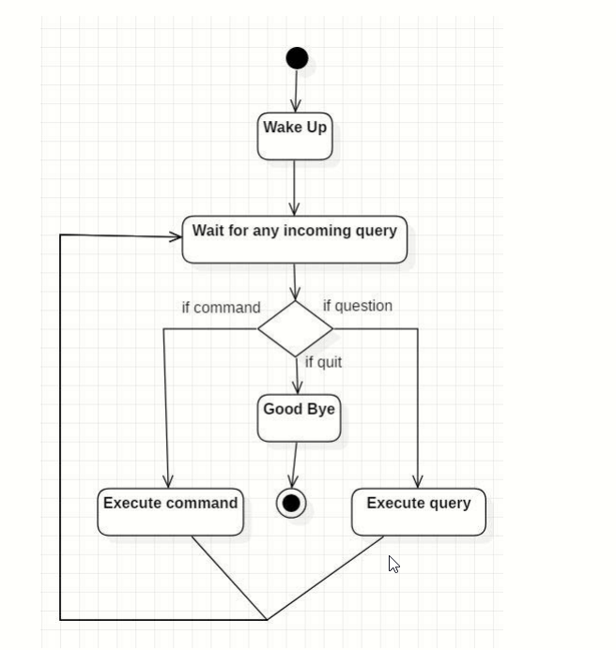

**Fig.2.1**

**(The block diagram of the algorithm of the Personal Virtual assistant)**

### Problem Result

#### Opening Application

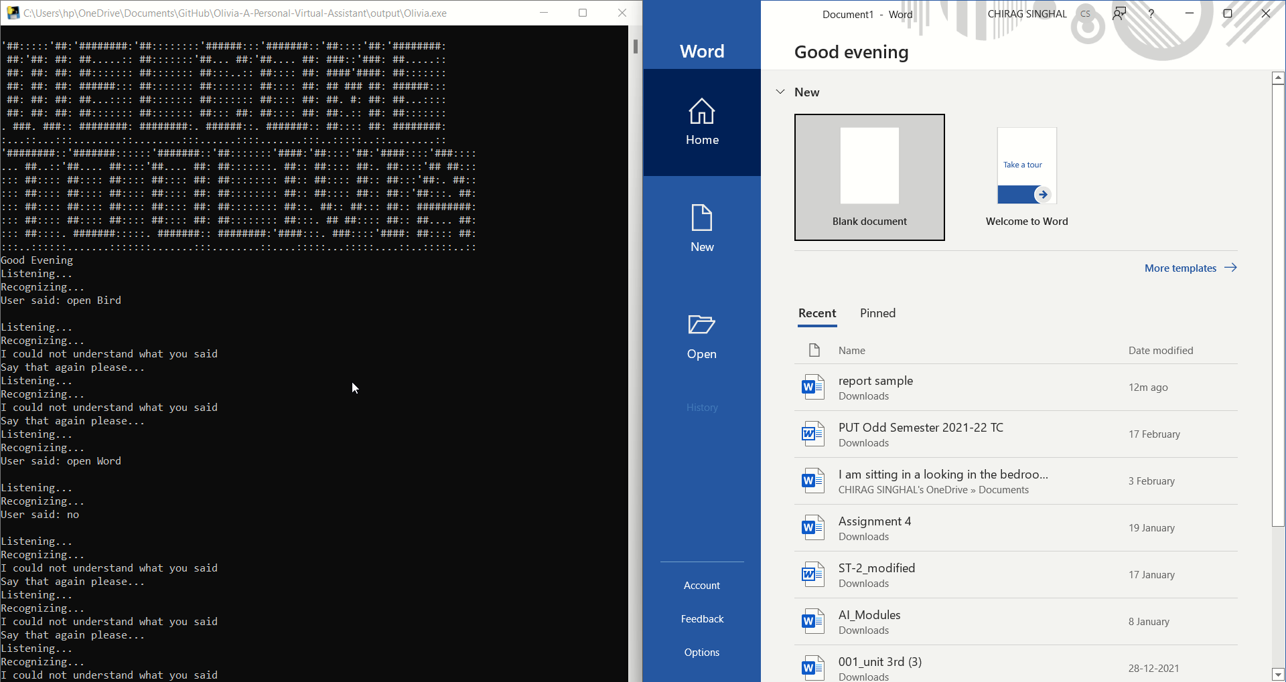

**Fig.2.2**

#### Playing video

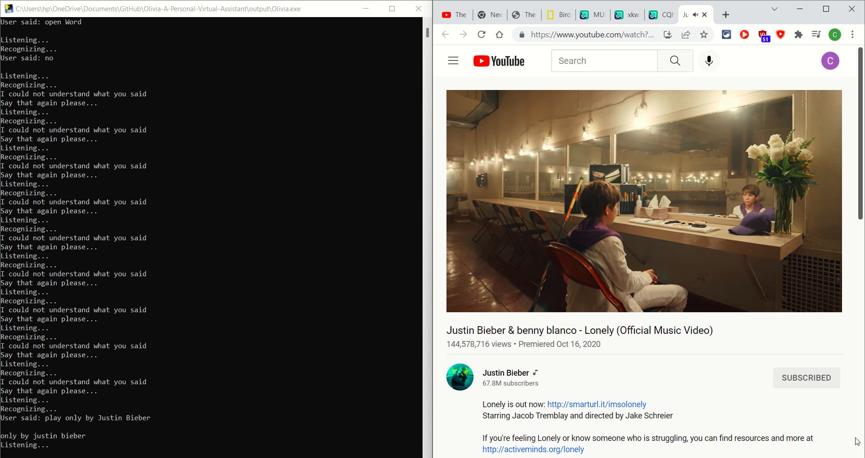

**Fig.2.3**

#### Translation

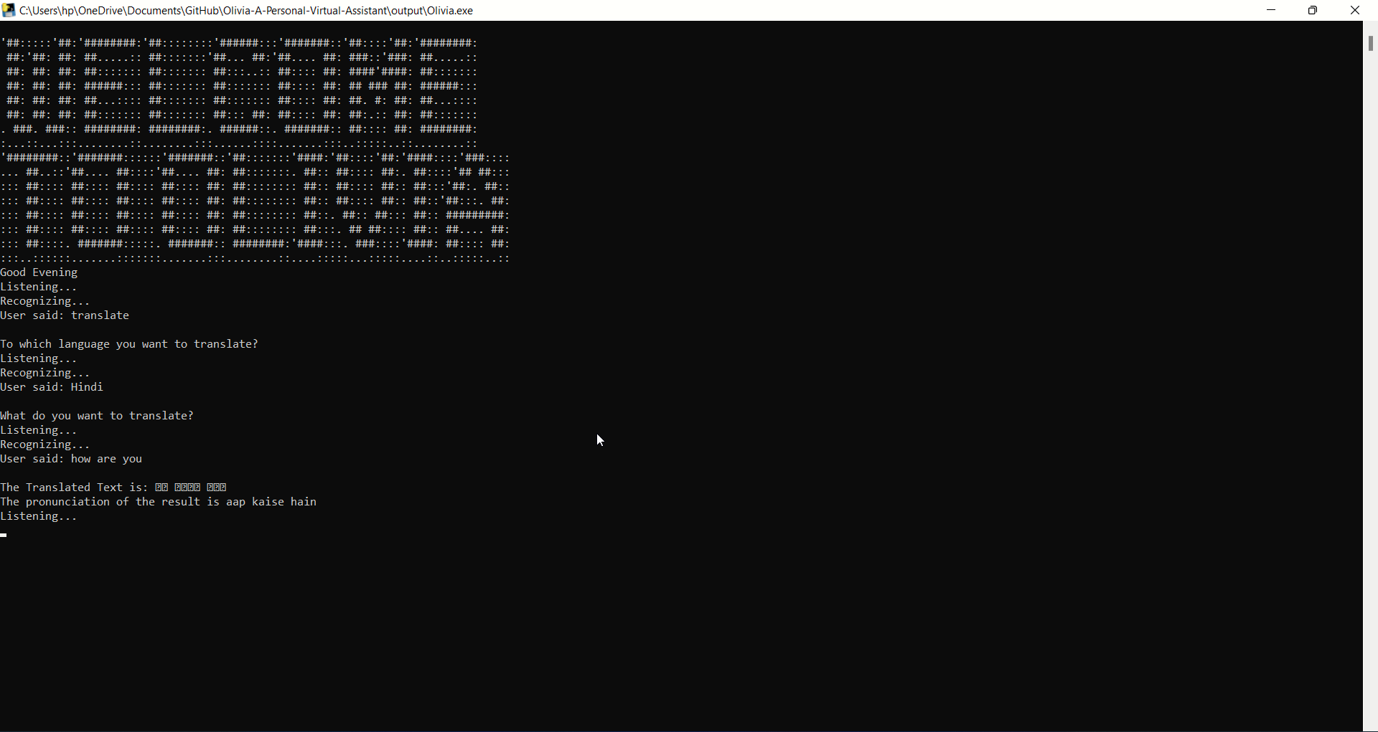

**Fig.2.4**

**CHAPTER 3**

# Project Specifications

### Hardware Requirements:

* 1. Processor : Intel Core i3 (minimum)
  2. Hard Disk : 40GB
  3. RAM : 256MB (minimum)

### Software Requirements:

* 1. Operating System : Windows 11, Windows 10, Windows 8.1, Windows Server 2019, Windows Server 2016
  2. Technology : Python

### Other Requirement

1. Internet connection - Speed of at least 1 Mbps
2. Ping - At most 100 ms
3. Jitter - At most 10 ms
4. Signal strength - At most -90 dBm
5. Noise - Silent or very low Background noise

### Consequences of background noise:

1. Background Noise may make the program fail to connect to the server.

2. Background noise may make the program fail to Recognize the spoke command or query.

### Consequences of bad internet connection:

1. Starting will take time.
2. Recognizing will take time.
3. The program may fail to connect to the server.
4. The program may fail to Recognizing the spoke saying.

### Basic Requirements

#### Natural Language Processing (NLP)

Natural language processing is a branch of artificial intelligence that deals with the interaction between computers and humans using the natural language. The ultimate objective of NLP is to read, decipher, understand, and make sense of the human languages in a manner that is valuable. It is the study of letting computers understand human languages. Without NLP, human language

sentences are just a series of meaningless symbols to computers. Computers don’t recognize the

words and don’t understand the grammars. NLP can be regarded as a “translator”, who will translate human languages to computer understandable information.

#### Artificial intelligence (AI)

Artificial intelligence refers to the simulation of human intelligence in machines that are programmed to think like humans and mimic their actions. for example- Speech recognition, Problem solving, Learning and Planning. The chatbot which we are making is an artificial intelligence program that creates conversational interaction between the chatbot and another user through audio command or text chat.

#### Deep Learning (DL)

Deep learning is a particular kind of machine learning that is inspired by the functionality of our brain cells called neurons which lead to the concept of artificial neural network

It is an artificial intelligence (AI) function that imitates the workings of the human brain in processing data and creating patterns for use in decision making. Deep learning is a subset of machine learning in artificial intelligence that has networks capable of learning unsupervised from data that is unstructured or unlabeled. Also known as deep neural learning or deep neural network.

CHAPTER 4

# Real World Applications

1. The main application of a voice assistant is to minimize the use of input devices like keyboard, mouse, touch pens, etc. This will reduce both the hardware cost and space taken by it.
2. The Olivia Personal Assistant is a voice assistant that can be used to perform tasks like playing music, playing games, playing videos, taking screenshots, sending emails, sending WhatsApp messages, etc.
3. The Olivia saves the user time and energy by providing a variety of functions.
4. The software is designed to be very useful for people with visual disabilities.
5. The software is designed to be very useful for people with physical disabilities like hand movements, hand-eye coordination, hand loss, etc.
6. The software is designed to be very useful for people with listening disabilities like hearing loss too.
7. The software is designed to be very useful for people with cognitive disabilities like autism, autism spectrum disorder, autism spectrum disorder, etc.
8. The software is designed to be very useful for people with speech disabilities like stuttering, speech impairment, etc.
9. The software is designed to be very useful for people with reading disabilities like dyslexia, etc.
10. The software is designed to be very useful for people with language disabilities like aphasia, bilingualism, etc.

# Conclusion

In this project we have used the basics of python. We have learned about the Natural Language Processing(NLP), Deep Learning(DL), Python modules and libraries. We also learned how to make a GUI for our application. This project teaches us how to create a basic chat application and how to get efficient responses from it. This assistant currently works online and performs basic tasks like weather updates, stream music, search Wikipedia, open desktop applications, etc. The functionality of the current system is limited to working online only. The upcoming updates of this assistant will have machine learning incorporated in the system which will result in better suggestions with IoT to control the nearby devices similar to what Amazon’s Alexa does.

# Future Scope

We can also make the software more intelligent by using the libraries like NLP, Natural Language Processing, Machine Learning etc. and provide more personalized assistance to the user. The virtual assistants which are currently available are fast and responsive but we still have to go a long way. The understanding and reliability of the current systems need to be improved a lot. The assistants available nowadays are still not reliable in critical scenarios. The future of these assistants will have the virtual assistants incorporated with Artificial Intelligence which includes Machine Learning, Neural Networks, etc. and IoT. With the incorporation of these technologies, we will be able to achieve new heights. What the virtual assistants can achieve is much beyond what we have achieved till now. Most of us have seen Jarvis, that is a virtual assistant developed by iron man which is although fictional but this has set new standards of what we can achieve using voice-activated virtual assistants.

# References

1. <https://www.geeksforgeeks.org/python-programming-language/>
2. <https://en.wikipedia.org/wiki/PyCharm>
3. <https://machinelearningmastery.com/natural-language-processing/>
4. <https://en.wikipedia.org/wiki/Artificial_intelligence>
5. <https://machinelearningmastery.com/what-is-deep-learning/>
6. <https://docs.python.org/3/library/tk.html>
7. <https://pypi.org/project/pyttsx3/>
8. <https://en.wikipedia.org/wiki/Virtual_assistant>
9. https://python.org/downloads/release/cpython/
10. https://en.wikipedia.org/wiki/Siri